APP Data Tool Quick Start Guide

V1.1

2018/09/12

Revision History

|  |  |  |  |  |
| --- | --- | --- | --- | --- |
| Date | Version | Modify | Author | Reviewer |
| **2018/09/12** | V1.0 |  | Grace |  |
| **2018/11/26** | V1.1 | Add section 2.3 and section 3 | Grace |  |

Contents

Revision History 2

1 Overview 4

2 Operation steps 5

2.1 APP Data1 5

2.2 APP Data2 5

2.3 APP Data3~6 6

3 Version management of APP Data 7

# Overview

APP Data Tool converts the original APP Data bin file into APP Data1 or APP Data2 type image that can be burned into External Flash by RTL8762E MP Tool. After APP Data Tool processes, it will add a 1KB image header and 512 bytes MP header in front of the original APP data, which are used for Bootloader check and MP Tool burning respectively. Assuming that the size of the bin file of the original APP Data is 120KB, the final burn to the flash will be 1KB image header plus 120KB APP data payload.

# Operation steps

## APP Data1

1. The directory of sdk\tool\AppData\AppData1 is as follows:

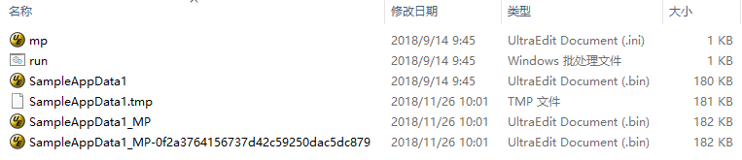

SampleAppData1.bin is the bin file of the original APP Data.

SampleAppData1_MP-0f2a3764156737d42c59250dac5dc879.bin is the APPData1 bin file generated by tool for burning.

1. Open “run.bat”, replace the following two parts with the bin file name of the APPdata to be processed. Note that the second line must be "xxx_MP.bin", and the suffix "_MP" cannot be changed. 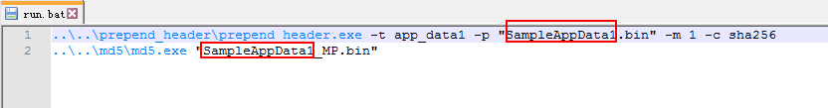
2. Run “run.bat”, three additional files will be generated:
3. SampleAppData1.tmp is a temporary file with 1KB image header added to the bin file of the original APP Data;
4. SampleAppData1_MP.bin is the bin file with 512 bytes of MP Header added to the temporary file;
5. SampleAppData1_MP-0f2a3764156737d42c59250dac5dc879: The MD5 check value is calculated on the basis of "xxx_MP.bin". Note that only bin files with both _MP and MD5 check can be used for burning and OTA.

## APP Data2

1. The directory of sdk\tool\AppData\AppData2 is as follows:

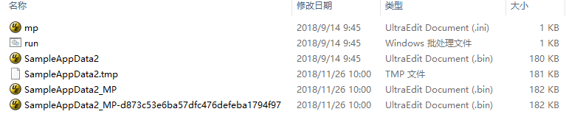

SampleAppData2.bin is the bin file of the original APP Data.

SampleAppData2_MP-d873c53e6ba57dfc476defeba1794f97.bin is the APPData2 bin file generated by tool for burning.

1. Open “run.bat”, replace the following two parts with the bin file name of the APPdata to be processed. Note that the second line must be "xxx_MP.bin", and the suffix "_MP" cannot be changed.



1. Run “run.bat”, three additional files will be generated:
2. SampleAppData2.tmp is a temporary file with 1KB image header added to the bin file of the original APP Data;
3. SampleAppData2_MP.bin is the bin file with 512 bytes of MP Header added to the temporary file;
4. SampleAppData2_MP-d873c53e6ba57dfc476defeba1794f97: The MD5 check value is calculated on the basis of "xxx_MP.bin". Note that only bin files with both _MP and MD5 check can be used for burning and OTA.

## APP Data3~6

If the Patch and SDK version you are using supports extended APP Data 3~6, use the corresponding directory file tool under sdk\tool\AppData for processing. The operation is similar to the processing of APP data1 and APP data2 above, so it won't repeat them here.

# Version management of APP Data

There is a "mp.ini” configuration file in the sdk\tool\AppData\AppDataX directory as shown in the figure below. By modifying the configuration file, you can generate bin files of different versions of APP data.

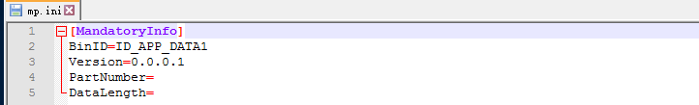

Among them, "Version=0.0.0.1" means the version of the generated APP data. The four-segment version number at this point indicates the version information "Major. Minor. Revision. Reserve", which occupies a total of 32 bits, corresponding to the following structure.typedef struct

{

union

{

uint32_t version;

struct

{

uint32_t _version_major: 4; //!< major version

uint32_t _version_minor: 8; //!< minor version

uint32_t _version_revision: 15; //!< revision version

uint32_t _version_reserve: 5; //!< reserved

} sub_version;

} ver_info;

uint32_t _version_commitid; //!< git commit id

uint8_t _customer_name[8]; //!< branch name for customer patch

} T_VERSION_FORMAT;

The version information will be stored in the git_ver field in the image header of the first 1KB, offset 0x60.

typedef struct

{

T_IMG_CTRL_HEADER_FORMAT ctrl_header;

uint8_t uuid[16];

uint32_t exe_base;

uint32_t load_base;

uint32_t load_len;

uint32_t img_base;

uint8_t rsvd0[4];

uint32_t magic_pattern;

uint8_t dec_key[16];

uint8_t rsvd1[28];

T_VERSION_FORMAT git_ver;

T_RSA_PUBLIC_KEY rsaPubKey;

uint8_t sha256[32];

uint8_t rsvd2[68];

uint32_t app_cb_signature;

uint32_t app_cb_table_base_address;

} T_IMG_HEADER_FORMAT;